Unit 1 discussion: Television Quality
- There are several programs that can be named as either “trashy” or “quality” in the TV shows. The classification of a TV show mainly depends on the type of education it provides to the society. Some of the “trashy shows” include the real housewives or the big brothers. The main reason I would term them as trashy is because they don’t provide positive education to the society. Their theme plots or even the subject matter does not have something that the society can learn from. For exam in the case of the real house helps it poses teaching of women who are money orientated as well as bitter with life and this is not the teaching the society should be acquiring from the TV shows. Some of the TV shows that can be classified as quality include shows like the game of throne or the 60 days in are good example of quality TV shows. They are termed as quality as they offer positive teaching to the society or the way the society is expected to live. Their theme, plot and teaching are in line with the expected way of life of the society. For example in the case of 60 days in the society acquires teaching on the life in prison and through this the society is warned against doing evil as the life that awaits one in prison is very hard.
- They are a number of shows that can be termed as universally trashy. The reason why I would term them universally trashy is because they are truly loved but only few people admit in to watching them. For example the reality TV is widely watched by people but in real sense it’s not real but only for entertainment.
- Yes its true America is seen to have very good taste especially when it comes to movies. Countries may not be fond off the TV shows but in real sense America got some of the leading TV shows as well as movies that in most Academy Awards.
- The Skyscraper model seems to make more sense to me as it is very easy to understand and interpret. It offers different levels of culture as they are classified. In the case of the chart it becomes hard for one to understand especially the meaning of each and every point.
Reference
Discovery Channel's Brand Purpose – ‘Satisfying Curiosity.’” MDH Mark D Hogan, 12 Apr. 2013, markdhogan.wordpress.com/2013/04/12/discovery-channels-brand-purpose-satisfying-curiosity/.
Responses
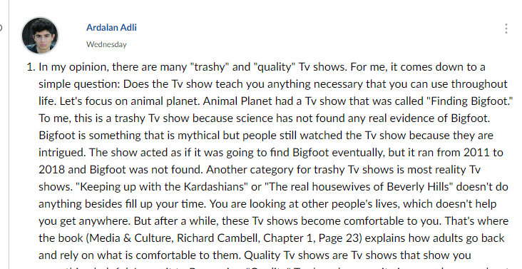
Hi Ardalan,
Good and interesting points over there. I like you idea especially in the case of reality shows for example keeping up with the Kardashian. They do not offer positive teaching to the society and hence are categorised as trashy. The people are made to believe that they offer teaching but in real sense they are just for showing off other people’s way of life. On the other hand in the case of the chart and a map, I agree with you that the map seems to make more sense to me as opposed to the chart as it gives a clear picture of the culture. It also gives different categories of culture. As for the case of people looking down upon the American movies I don’t that the case as many people view them as of high quality.
Student 2.respond
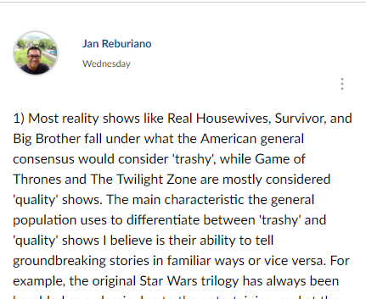
Hi Jan,
Good and amazing points over there your idea about the chart and model. The idea is very good as they are both important especially when coming up with the history about the culture. Both the chart and the model have a role that they can play which is unique in its own way. Also in the case of America being famous in Hollywood movies I also agree with you as Hollywood movies are one of the most known movies in the whole world. I also like your ideas which you have accompanied with what other writers thought about the same idea whether they support it or not. Another case where I find your points powerful are where you find it hard to name a given TV show as trashy as we all have different views about different issues in the society.

